**REPORT**

**OF**

**MY PERSONAL CDS PROJECT**

**ON**

**DRUG ABUSE**

**AT**

**BAUCHI LGA**

**BY**

**ADEOYE RUTH ADENIKE**

**BA/19A/1221**

**EXECUTIVE SUMMARY**

Adeoye Ruth Adenike, a serving corp member posted to Hospital Management Board, currently serving at Infectious Diseases Hospital, Bayara, Bauchi State with the State code BA/19A/1221 conducted a HIV Testing Services at Bayara Community, Bayara Market on the 27th January, 2020. The HIV Testing Services commenced at exactly 11am at the market with a team of 11 members.

* Two members of staff of Rahama Women Organization was there to handle the counseling session.
* Five members of Anti-HIV Community Development Service group.
* Two members of Publicity and Editorial Community Development Service group.
* One member of NDLEA Community Development Service group.

Advocacy visit was paid to the Sherki of the community on the 21st of January, 2020, the market secretary and market security personnel.

Present at the market place for monitoring and evaluation of the activity was:

* FHI 360 HIV Focal Person, Mr Joshua.
* Two FHI 360 case managers from Infectious Diseases Hospital, Bayara.

A total no of fifty (50) client were voluntarily tested and counseled with no positive case.

**TOTAL EXPENDITURE**

|  |  |  |  |  |
| --- | --- | --- | --- | --- |
| S/N | ITEMS | QUANTITY | UNIT COST | TOTAL COST |
| 3 | Refreshments for team members | 11 | 200 | 2,200 |
| 4 | Placards (cardboards and markers) | 4 | 50 | 200 |
| 7 | Refreshments for stakeholders present. | 2 | 500 | 1,000 |
| 8 | Team members transport charges | 11 | 200 | 2,200 |
| 9 | Total transport charges in getting the kits and people. | 1 | 1000 | 1000 |
| 10 | Total printing cost |  | 500 | 500 |
|  | **TOTAL** |  |  | 7,100 |

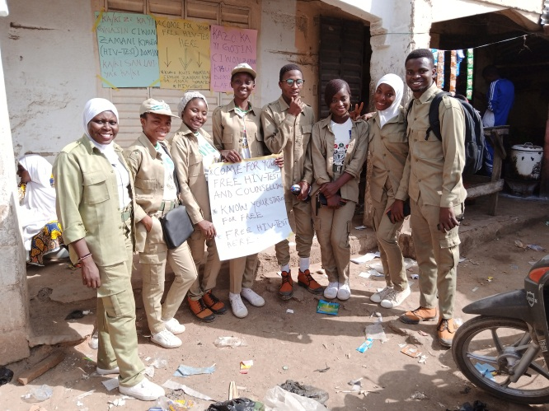 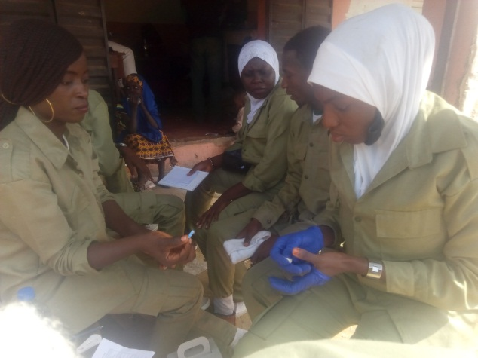

***The above picture shows Corp member Adeoye Ruth Adenike with batch no BA/19A/1221 and her team members after the HIV Testing Services at Bayara market.***

***The second picture shows team members conducting the HIV test for one of the team members.***

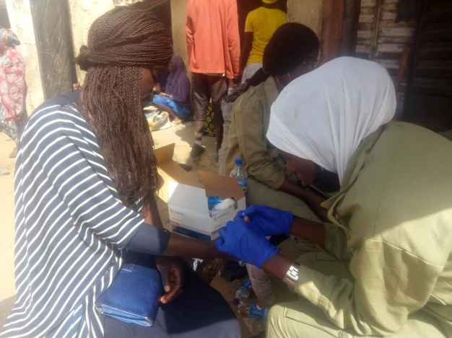 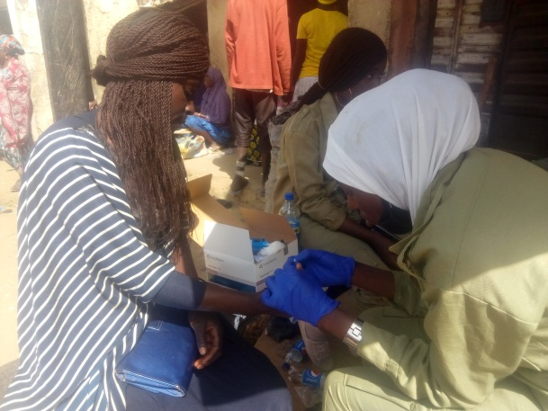

***Corp member Adeoye Ruth Adenike’s t eam members conducting HIV test for clients.***

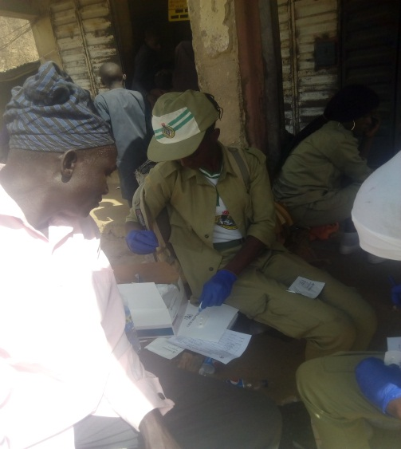 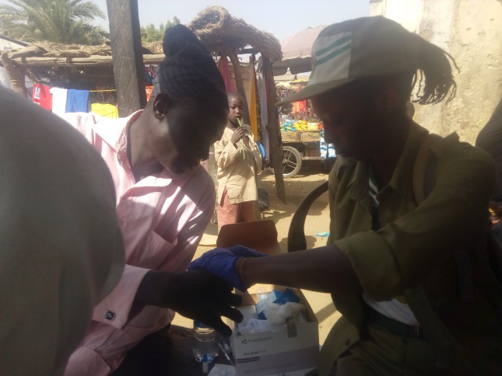

***Corp member Adeoye Ruth Adenike conducting voluntary HIV test for the client.***

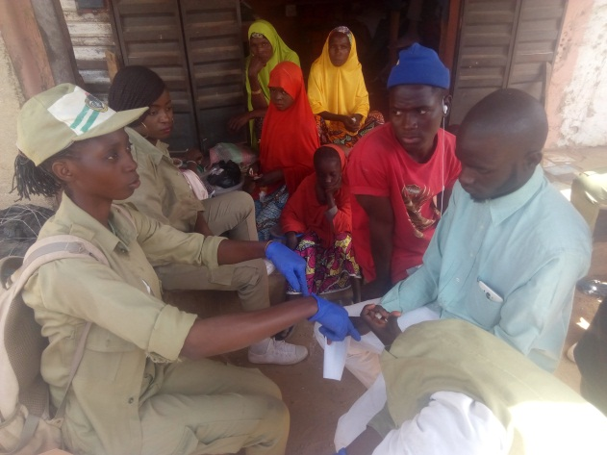 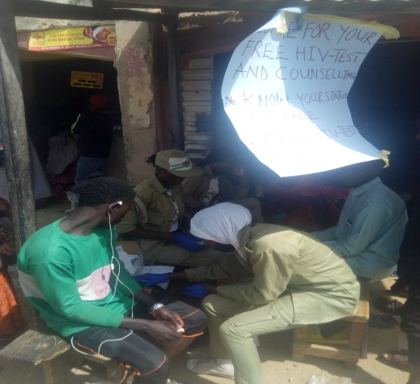

***Corp member Adeoye Ruth Adenike and team members conducting voluntary HIV test for the client.***

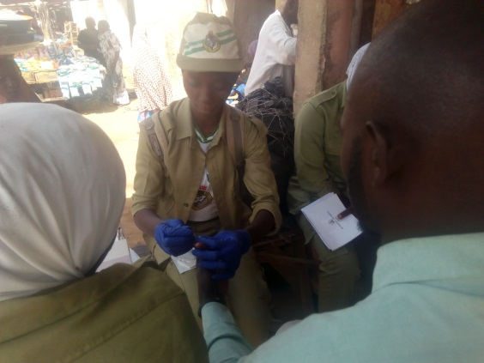 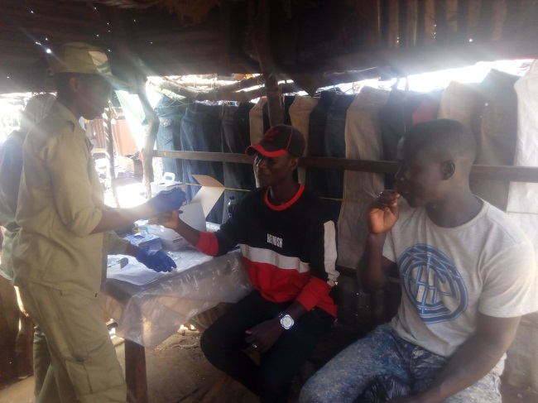

***Corp member Adeoye Ruth Adenike conducting voluntary HIV test for the client.***

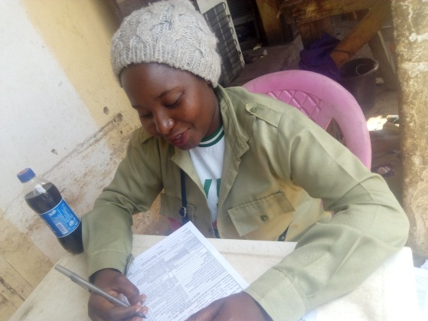 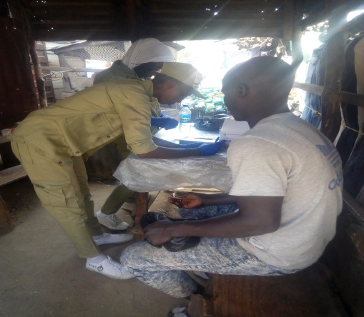

***Corp member Adeoye Ruth Adenike team member documenting client’s details before conducting voluntary HIV test for clients.***

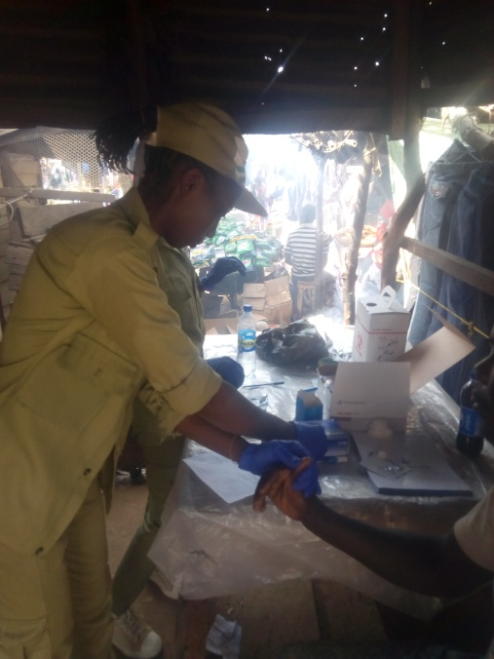 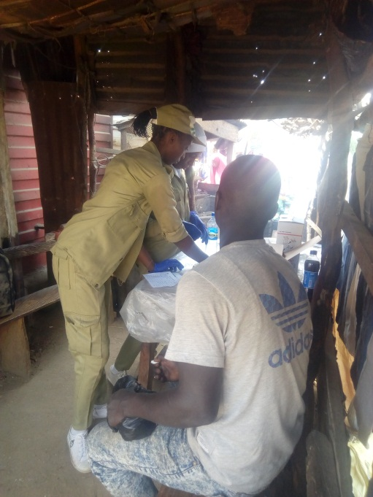

***Corp member Adeoye Ruth Adenike conducting voluntary HIV test for the client.***

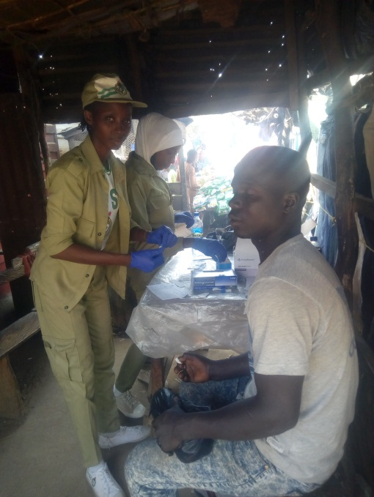 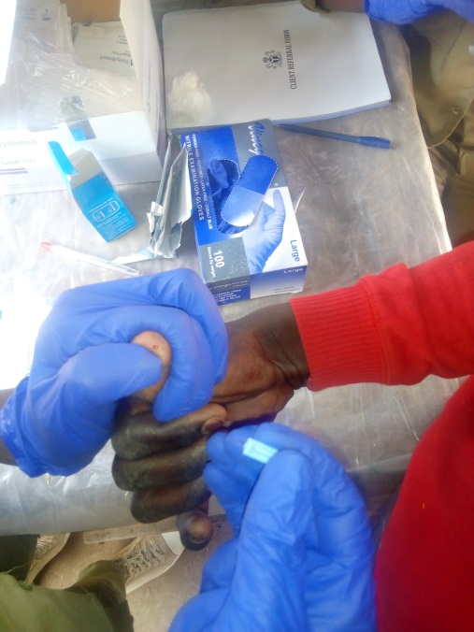

***Corp member Adeoye Ruth Adenike conducting voluntary HIV test for the client.***

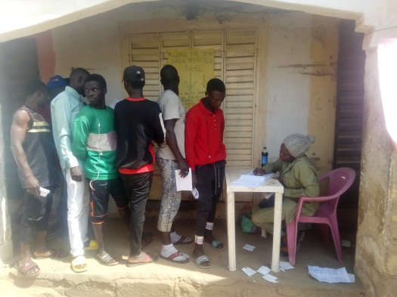 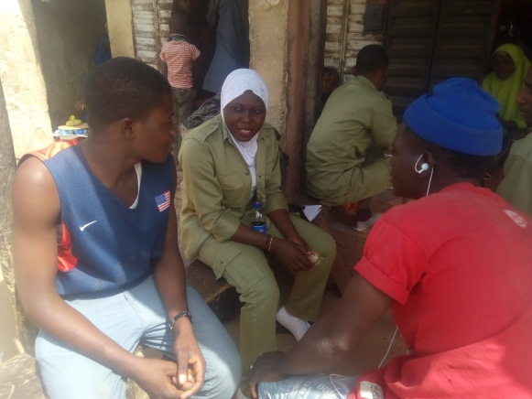

***Corp member Adeoye Ruth Adenike team member documenting client’s details before conducting voluntary HIV test for client.***

***The second picture shows the counseling session by Corp member Adeoye Ruth Adenike team members.***

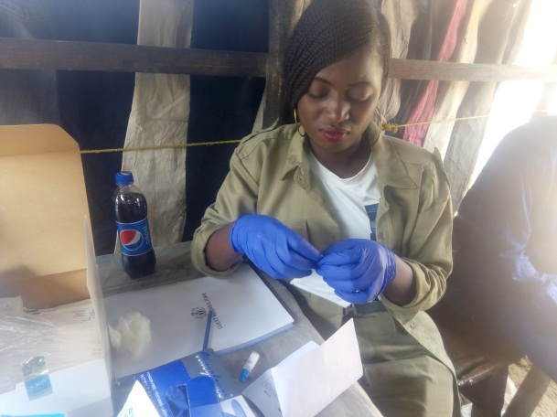 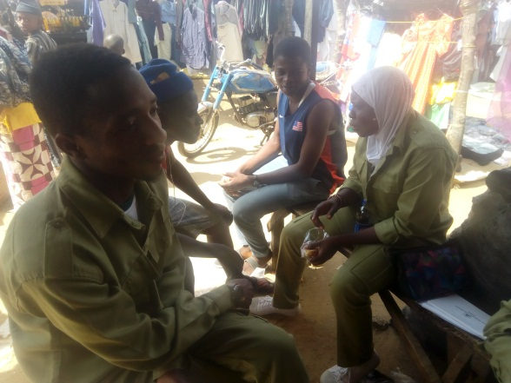

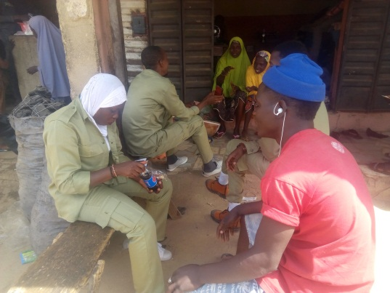 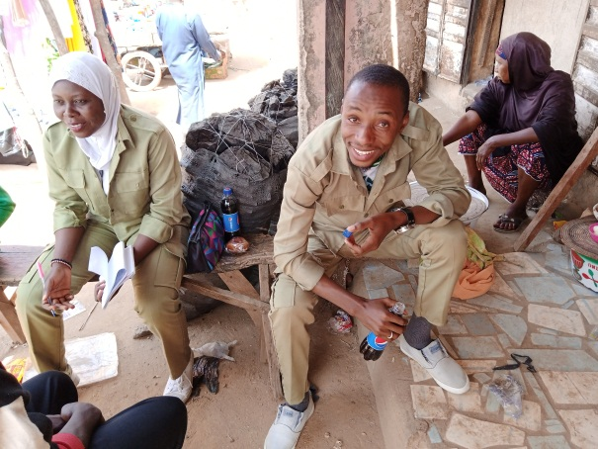

***Corp member Adeoye Ruth Adenike team member taking their refreshments after the post counseling session.***

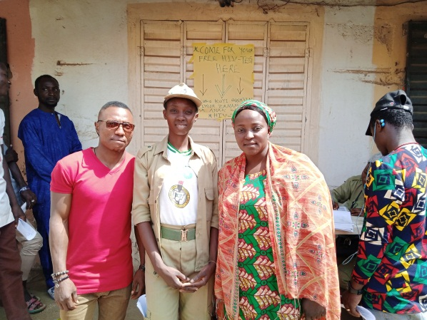 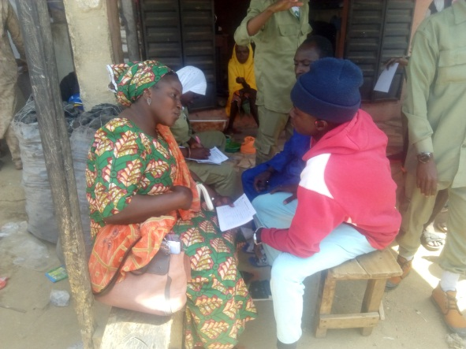

***Corp member Adeoye Ruth Adenike with representatives from Rahama Organization during pre-counseling and after the HIV Testing Services at Bayara Market.***

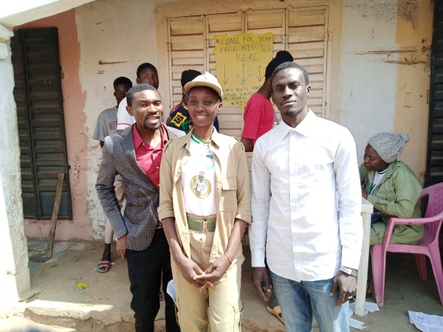 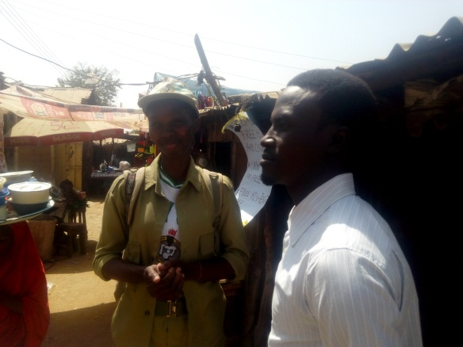

***Corp member Adeoye Ruth Adenike with the FHI360 Case managers from Infectious Diseases Hospital, Bayara during the program.***

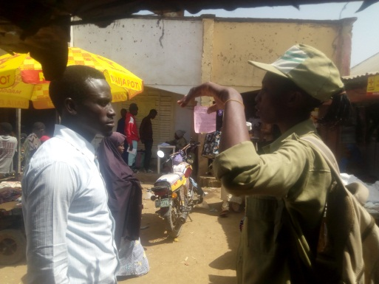 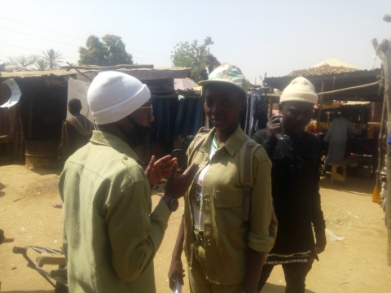

***Corp member Adeoye Ruth Adenike giving progress report to one of the FHI360 case manager during the program at Bayara Market.***